

Botanical Garden University of Karachi, Karachi, Pakistan

## GALLEY PROOF

**Office: 021-36073119**

#### Date: 19-03-2019

**Dr. Razi Abbas**

Department of Biological Sciences, Forman Christian College, Lahore, Pakistan.

**Dear Dr. Razi Abbas,**

Enclosed is the galley proof of your paper MS No. 2018-277 for its publication in the Pakistan Journal of Botany, Volume No. 51(4): issue 2019. I shall be obliged if you could kindly make necessary corrections and return it to us as early as possible. Besides you will have to bear the printing charges **Rs. 10000/-** which may kindly be deposit online in the given account. Please return **SOFT COPY** of the galley proof with correction if necessary as soon as possible and do not disturb our **PJB FORMAT**.

**Account Details**

A/C title: Chief Editor Pakistan Journal of Botany

A/C no.: 371-0028-5

Banker: United Bank Limited (UBL)

Branch code: 1146

Bank address: University of Karachi, Karachi, Pakistan.

Swift code: UNILPKKA

IBAN: PK24UNIL0112114637100285

With regards and best wishes,

Yours Sincerely,



**(Dr. Muhammad Qaiser)**

**Chief Editor**

**Pakistan Journal of Botany**

**University of Karachi, Pakistan**

**EVALUATION OF POTENTIAL OF *EPIPREMNUM AUREUM* ENGL. IN REMOVING ZINC (Zn) TOXICITY**

**RAZI ABBAS1, SAMINA MEHNAZ2 AND AISHA SALEEM KHAN3**

*1Department of Biological Sciences, Forman Christian College, Lahore, Pakistan*

*2Department of Biological Sciences, Forman Christian College, Lahore, Pakistan*

***3****Department of Biological Sciences, Forman Christian College, Lahore, Pakistan*

*Corresponding author’s email: aishasaleemkhan@fccollege.edu.pk*

**Abstract**

In the current research, money plant *(Epipremnum aureum* Engl.), an indoor plant which is a member of family Araceae was studied in order to explore its potential in the phytoremediation of zinc (Zn), which is toxic for the plant in higher concentrations. Selected plant*s* were treated with different concentrations of ZnCl2 as Zn is known to be toxic for plant growth and development in higher concentration. Doses of ZnCl2 were applied at concentration of 10, 20 and 30ppm which resulted in degradation of chlorophyll, reduction of leaf lamina and inhibition of vascular growth of leaves and stem. Stomata of ZnCl2 treated plants remained closed with higher doses followed by overall reduction in leaf growth which was further revealed through spectrometric techniques. However, as roots did not show any visible symptom of Zn toxicity but accumulation of Zn within stem and leaf tissues (as shown through atomic absorption spectrometry) suggested that plant was capable of translocating Zn to aerial parts, therefore could be used to solve problems caused by Zn toxicity.

**Keywords:** Hyperaccumulator, Money plant, Toxicity, Vascular tissue, Zinc

**Introduction**

Heavy metals are released into the environment due to increase in industrialization, mining activities, traffic exhaust, through excessive use of pesticides, and herbicides. Many of them like chromium (Cr), cadmium (Cd), lead (Pb), mercury (Hg) and zinc (Zn) are toxic for plants and animals. They are causing many health problems and are also responsible for a decrease in the number of many economically important plants. In response to heavy metals pollution, waste management techniques like phytoremediation are gaining more attention in the past few decades than any other technique in order to remove pollutants from the environment through the use of hyperaccumulators. Hyperaccumulators are plants which can accumulate metals almost 50-100 times higher than non-accumulating plants ((McGrath & Zhao, 2003; Emamverdiani and Ding, 2018). They accumulate metals within their different tissues and can either convert them in a form which is not even toxic for plants or can uptake heavy metals in their aerial parts which can later be harvested. The most important application of the phytoremediation is that it ensures the removal of the unwanted toxic materials from the site of pollutants without harming any other neighboring plants. Heavy metals are known to cause inhibition in seed germination (Baek *et al*., 2012; Khattak *et al*., 2015; Soudek *et al*., 2010), reduction in vascular tissues (Khan *et al*., 2016) and cause damage to photosynthetic pigments (Singh *et al*., 1996; Strzalka *et al*., 2013; He *et al*., 2016; Jiang *et al*., 2018). Heavy metals like Pb and Hg are reported to cause delay in floral initiation (Chaudhry & Khan, 2006) and accumulation of calcium oxalate crystals (Khan & Rehan, 2014). Further, they also affect the proteomics of many plants which results in oxidative stress (Garcia *et al*., 2006; Jiang *et al*., 2018).

The major releasing sources of Zn in the environment are the electroplating, mining and smelting during the ore processing and different industrial procedures like alloy making and paint manufacturing. Plants and microbes have great potential to absorb Zn. It also interferes with the activity of chlorophyll 'a' and 'b' by inhibiting the activity of enzymes involved in their photosynthesis (Paz-Alberto & Sigua, 2013; Emamverdiani & Ding, 2018). In Pakistan, higher Zn levels are detected in drinking water in many areas of Peshawar and Punjab including Multan, Kasur, Dera Gazi Khan, Sialkot as well as urban areas of Lahore. Futher, Zn pollution also exists as road dust pollution along Islamabad Expressway, Pakistan.

Current research work was undertaken to explore the potential of *E.aureum* as hyperaccumulator of Zn through anatomical and spectrometry techniques. Money plant was selected due to its availability all the year round, its importance as an ornamental indoor plant and also due to its ability to grow in soil as well as in water. Further, there is also increasing interest of environmentalists in using money plant for removing pollutants like lead and chromium.

**Materials and Methods**

Following methodologies were used to meet the objectives of this research:

**Plant cuttings:** Money plant cuttings were obtained from the botanical garden of Forman Christian College (A Chartered University). Plants were young and almost of same size. They were placed in beakers containing water and were marked according to their treatments. Five replicates were selected for each treatment. The solutions in the beakers were replaced at regular intervals (every week) and were maintained under the natural conditions of light, temperature and humidity. Different concentrations of ZnCl2 were applied individually at 10 ppm ZnCl2, 20 ppm ZnCl2 and 30 ppm ZnCl2. In one set of beakers, no ZnCl2 was applied and that group was treated as control.

**Morphological and anatomical analysis:** Amongmorphological parameters, changes in color of roots and number of root hairs were recorded. Size and color of leaves were noted on weekly basis. Length of stem and leaf texture were also observed in control as well as treated plants. Further, number of open and closed stomata were recorded during different time intervals. All parameters were compared with the parameters of untreated control plants.

For anatomical analysis, slides of transverse and longitudinal sections of roots and stems were prepared and viewed and photographed under light microscope (MT5300H-Meiji Techno, Japan). Both hand-sectioning and microtomy was done to observe changes in structure caused by ZnCl2. Sanderson (1994) method was used for microtomy. Samples were fixed in immediately in Corney's modified fluid. Fixation was followed by dehydration which involved gradual increase of ethanol in order to make tissues clear. After dehydration samples were infiltrated with granular paraffin wax (Merck). It was carried out in an embedding oven, at 55°C to 60°C by giving several washes with paraffin wax, until the wax became transparent. It was followed by formation of embedding blocks and fixing the tissues surrounded by paraffin on the wooden blocks after trimming. Sections were cut with the help of a rotary microtome and ribbon was placed in a warm water tray and then affixed to the clean slides with adhesive comprising of 50% egg albumin and 50% glycerine. Staining was done in toluidine blue stain. Canada balsam was used to coat slides permanently. Hand-sectioning was done using the toluidine blue stain for the differentiation of vascular tissues.

All slides were observed at 10X and 40X, however; the sizes of cells were studied at 10X. The length and diameter of cells were recorded with the help of ocular micrometer. The data obtained was converted into micron meters (μm) with the help of stage micrometer. In slides of roots and stem, parameters evaluated in the transection were the diameter of cortical and vascular cells of roots. Diameters of vascular bundles, cortical cells and pith cells in cross sections of roots and stem were also studied. However, changes in number of open and closed stomata as well as shape of guard cells were recorded in leaves.

**Chlorophyll Estimation:** Chlorophyll estimation was done in order to estimate the chlorophyll content of the control plants as well as plants treated with different concentrations of ZnCl2 (10ppm, 20ppm, 30ppm). Chlorophyll is not water soluble, thus special laboratory grade acetone was used instead of the water. Leaves of all treatments including control were weighed and cut into small pieces and then crushed using pastel and mortar. For the chlorophyll mixing 5 ml of 80% acetone was used. Then rinsing was done using 1 ml of the acetone. Acetone (80%) was added to raise the final concentration till 10 ml. For further measurement of chlorophyll, 3ml of the acetone from the supernatant of the glass tube containing the mixture of crushed leaves was shifted to cuvette. The wavelength was first set at 663 nm and 80% acetone was used to blank the UV/ VIS spectrophotometer.

The chlorophyll concentration was determined using (Arnon, 1949) method of chlorophyll estimation.

Chlorophyll ‘a’ (mg/g) = [(12.7 × A663) – (2.6 × A645)] × milliliters of acetone / milligrams of leaf tissue

Chlorophyll ‘b’ (mg/g) = [(22.9 × A645) – (4.68 × A663)] × milliliters of acetone / milligrams of leaf tissue

Total chlorophyll (mg/g) = Chl ‘a’ + Chl ‘b’

**Atomic Absorption Spectroscopy (AAS):** Atomic absorption spectrophotometry was done in order to check the amount of Zn accumulated in the plant parts (root and stem). For this purpose, 0.1g sections of root and stem were weighed and heated in a mixture containing 25ml of concentrated nitric acid and 10ml of concentrated sulphuric acid (Hseu, 2003). Both root and stem sections were heated under the fume hood and beaker was covered with the watch glass to avoid acid fumes. The fixed sample was then transferred to the volumetric flask and volume was raised up to the desired level using the distilled water. All the readings were recorded using the atomic absorption spectrophotometer (Varian AA 240 F.S., USA).

**Results and Discussion**

The present study revealed that money plants treated with all doses of 10ppm, 15ppm and 30ppm ZnCl2 did not show significant changes in color, size, and growth of roots and root hairs after one month when compared with control plants. However, a noticeable decrease in amounts of chlorophyll ‘a’ and ‘b’ was seen especially at dose of 30ppm ZnCl2 (Fig 1, Table 1). Decrease in amount of chlorophyll was observed in all doses of ZnCl2 although the amount of chlorophyll 'a' was reported to be less as compared to chlorophyll 'b' (Table 1). Reduction in the chlorophyll content might be due to the inhibition of enzymes and cofactors required for the chlorophyll synthesis due to accumulation of ZnCl2 (Paz-Alberto and Sigua, 2013; Strzalka *et al*., 2013; Jiang *et al*., 2018). These results also showed that Zn was translocated from root to aerial parts of plants which was further confirmed through atomic absorption spectrometry.

Anatomical analysis of roots did not show significant reduction in cortical region in both transection as well as in longitudinal view at doses of 10 and 20 ppm ZnCl2 as compared with dose of 30ppm (Fig 2-6, Table 2). Cortical cells of roots at 10ppm and 20ppm ZnCl2 treatments showed 25 % decrease as compared to control (Table 2), while dose of 30 ppm treated ZnCl2 showed a decrease of 41%. However, xylem cells at dose of 10 ppm and 30 ppm ZnCl2 revealed a 25 %increase which might be due to the fact that Zn is also a phytonutrient. Phloem cells in case of 10 ppm and 20 ppm ZnCl2 showed no significant increase or decrease but at dose of 30 ppm ZnCl2 treatment, 50 % increase was observed. (Table 2). These results suggest that roots of money plants are resistant to ZnCl2 at lower doses as far as morpho-anatomical results are related. However, AAS revealed the sequence of Zn accumulation in roots as 10 ppm (9.7544 mg/L) > 20 ppm (8.5845mg/L) > 30 ppm (8.2449mg/L).

In aerial parts i.e., stem and leaves, Zn accumulation was reported through AAS and anatomical results showed reduction in vascular tissues of stem at all doses (Fig. 7- 11, Table 3). Diameter of cortical cells, xylem and phloem were measured in the control plant as well in all Zn treated plants (Table 3). Doses of 10ppm and 20ppm (ZnCl2) treated xylem cells showed 25% decrease in their diameters while a decrease of 33% was observed at dose of 30ppm ZnCl2 suggesting that relatively higher doses of ZnCl2 reduce the growth of vascular tissues. Further, phloem cells at dose of 10ppm treated ZnCl2, showed 12% decrease in diameter whereas 30% decrease was observed in case of 20pmm and 30 ppm (ZnCl2) (Table 3). The reason might be due to Zn accumulation in the stem cells had might caused decrease in cell size. Further, stomata were reported to be closed at dose of 30ppmZnCl2 (Fig. 12-13) as compared with control which might be attributed to negative effects of Zn on leaf tissues and damage to photosynthetic pigments. These results suggested that money plant is capable of translocating Zn to aerial parts where it interferes with the xylem and phloem functioning and affects photosynthetic pigments which is also reported by Blasco *et al*., (2015) and Emamverdiani and Ding (2018). However, role of money plants as a possible hyperaccumulator of Zn requires further research work and identification of protein channels which are involved in Zn translocation.

**Conclusion and Future Perspectives:** Based on this research work, it is suggested that money plant has potential to accumulate Zn in roots without showing any visible symptoms of Zn toxicity. Uptake of Zn was confirmed through spectrometric analysis. Further, plant is also capable of translocating Zn to aerial parts as Zn accumulation in stem and leaves. This was confirmed through atomic absorption spectroscopy. In aerial parts, Zn caused reduction in amount of chlorophyll and vascular tissues of stem. However, role of money plant in phytoremediation can be studied further at molecular level by identifying protein channels which are involved in Zn translocation or through studying metabolic pathways to declare the role of this plant as a potential hyperaccumulator of Zn.

**References**

Arnon, D.I. 1949. Copper Enzymes in Isolated Chloroplasts. Polyphenoloxidase in *Beta vulgaris Plant Physiology*., 24(1): 1-15.

Baek, S.A., T. Han, S.K. Ahn, H. Kang, M.R. Cho, S.C. Lee and K.H. Im. 2012. Effects of heavy metals on plant growth and pigment contents in *Arabidopsis thaliana*. *J. Plant Pathol*., 28(4): 446-452.

Blasco, B., N.S. Graham and M.R. Broadley. 2015. Antioxidant response and carboxylate metabolism in *Brassica rapa* exposed to different external Zn, Ca, and Mg supply. *J. Plant Physiol*., 176: 16-24.

Chaudhry, N.Y and A.S. Khan. 2006. Improvement of pistillate flowers yields with GA3 in heavy metals treated plants. *Plant Growth Regul*., 50: 211-217.

Emamverdiani, A and Y. Ding. 2018. Effects of inhibition threshold in heavy metals on the growth and development of *Arundinaria fortunei*. *Pak. J. Bot*., 50(3): 887-892.

Garcia, J.S., P.L Gratao, R.A. Azevedo and M.A. Arruda. 2006. Metal contamination effects on sunflower (*Helianthus annuus* L.) growth and protein expression in leaves during development. *J. Agric. Food Chem*., 54(22): 8623-8630.

He, J., Z. XJi, Q.Z. Wang, C.F, Liu and Y.B. Zhou. 2016. Effect of Cu and Pb pollution on the growth and antioxidant enzyme activity of *Suaeda heteroptera*. *Ecol. Eng*., 87: 102-109.

Hseu, Z. 2003. Evaluating Heavy Metal Contents in Nine Composts Using Four Digestion Methods. *Biosource Technology*., 95: 53-59.

Jiang, L., L.K. Zhang and C. Tian. 2018. Copper-induced similar changes in growth and physiological responses of plants grown from dimorphic seeds of *Suaeda salsa*. *Pak. J. Bot.*, 50(3): 871-877.

Khattak, M.I., R. Jabeen, M. Hameed and Y. Arfat. 2015. A study of some heavy metals found in medicinal plants (*Euphorbia cornigera,* *Rhazya stricta* and *Citrullus colocynthis*) in Turbat region of Balochistan with reference to prevention of environmental pollution. *Pak. J. Bot*., 47(4): 1511-1516.

Khan, A.S. and Rehan S. 2014. Environmental factors affect calcium oxalate crystals formation in *Tradescantia pallida* (Commelinaceae). *Pak. J. Bot.*, 46(2): 477-482.

Khan, A.S., M.W. Hussain and K.A. Malik. 2016. A possibility of using waterlily (*Nymphaea alba* L.) for reducing the toxic effects of chromium (Cr) in industrial wastewater. *Pak. J. Bot*., 48(4): 1447-1452, 2016.

McGrath, S.P and F.J. Zhao. 2003. Phytoextraction of metals and metalloids from contaminated soils. *Curr. Opin. Biotechnol*., 14: 277-282.

Paz-Alberto, A. and G Sigua. 2013. Phytoremediation: A Green Technology to Remove Environmental Pollutants. *American J. Climate Change.*, 2: 71-86. doi:10.4236/ajcc.2013.21008.

Sanderson, J.B. 1994. Biological and Microtechniques. BIOS Scientific Publishers Limited, St Thomas House, Becket Street, Oxford, OXI ISJ, UK.

Singh, R.P., S. Dabas and A. Chaudhry. 1996. Recovery of Pb2+ caused inhibition of chlorophyll biosynthesis in leaves of *Vigna radiata* (L.) Wilczek by inorganic salts. *Indian J. Exp. Biol*., 34: 1129-1132.

Soudek, P., A. Katrusakova, L. Sedlacek, S. Petrova, V. Koci, P. Marsik, M. Griga and T. Vanek. 2010. Effect of heavy metals on inhibition of root elongation in 23 cultivars of flax (*Linum usitatissimum* L.). *Arch. Environ. Contam. Toxicol*., 59: 194-203.

Strzalka, K., A. Kostecka-Gugaa and D. Latowski. 2003. Carotenoids and environmental stress in plants: significance of carotenoid-mediated modulation of membrane physical properties. *Russ. J. Plant. Physiol*., 50: 168-172.

(Received for publication 29 March 2018)

**Please check all references in the text and reference list carefully some are missing from the list or not cited in the text**

**Send high resolution, sharp and clear images of all Figs. in TIFF format separately**

**Fig.1 is poor can not publish in present form send clear image**

|  |  |  |  |
| --- | --- | --- | --- |
| (a) | (b) | (c) | (d) |

Fig. 1. Set of money plants treated with different concentration of ZnCl2 (a) Control (b) Plants treated with 10ppm ZnCl2 (c) Plants treated with 20 ppm ZnCl2 (d) Plants treated with 30ppm ZnCl2

**Fig.1 is poor can not publish in present form send clear image**

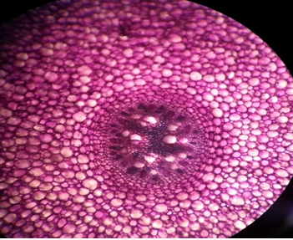

Fig. 2. Control root (40X)

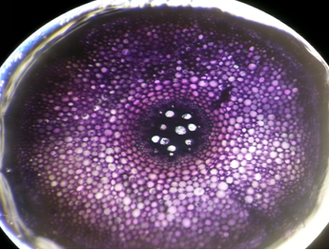

Fig. 3. 20 ppm ZnCl2 treated root (40X)

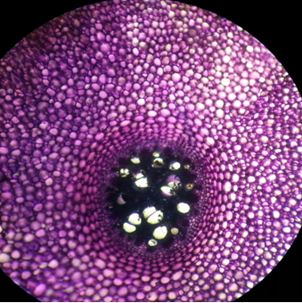

Fig. 4. 30 ppm ZnCl2 treated root (40X)

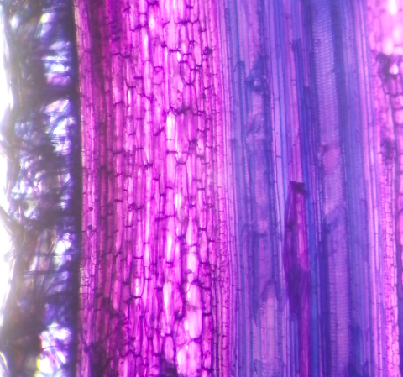

Fig 5. Control root in longitudinal view (10X)

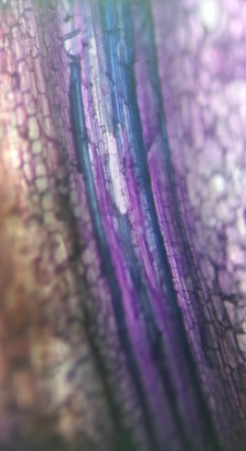

Fig. 6. 30 ppm ZnCl2 treated root in longitudinal view (10X)

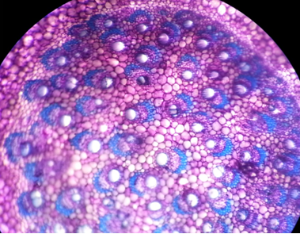

Fig. 7. Control stem (10X)

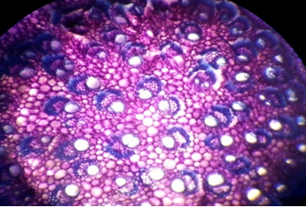

Fig. 8. 20 ppm ZnCl2 treated root (10X)

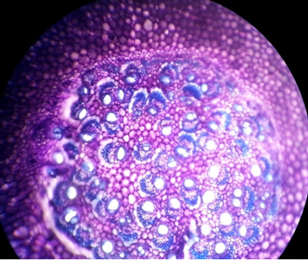

Fig 9. 30 ppm ZnCl2 treated root (10X)

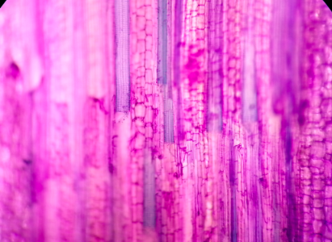

Fig. 10. Control stem in longitudinal view (10x)

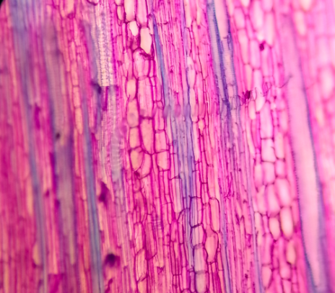

Fig. 11. 30 ppm ZnCl2 treated stem in longitudinal view (10X)

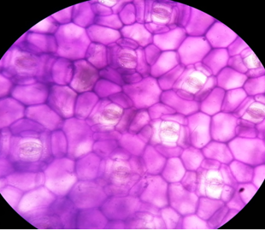

Fig. 12. Leaf epidermal of control showing

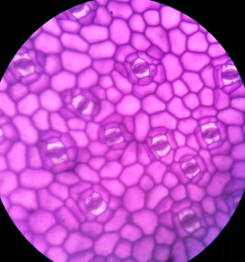

Fig. 13. Leaf epidermis of 30ppm ZnCl2 (40x) partly opened stomata (40x)

|  |  |  |  |
| --- | --- | --- | --- |
| Table 1. Effects of doses of ZnCl2 on chlorophyll ‘a’ and ‘b’ in *E. aureum* | | | |
| **Treatments of ZnCl2 (ppm)** | **Amount of chlorophyll (mg/g)** |  |  |
|  | Chl. ‘a’ mg/g Mean ± SD | Chl. ‘b’ mg/g Mean ± SD | | |
| Control | 13.89±9.17 | 19.4±13.37 | | |
| 10 | 9.78±8.04 | 13.90±11.33 | | |
| 20 | 9.7±7.31 | 14.10±10.60 | | |
| 30 | 7.84±5.03 | 10.3±6.76 | | |

|  |  |  |  |
| --- | --- | --- | --- |
| Table 2. Average diameter of root of *E. aureum* in comparison with different doses of ZnCl2 | | | |
| Treatments | Cortex cells (µm) | Xylem(µm) | Phloem(µm) |
| Control | 192 | 64 | 48 |
| 10ppm (ZnCl2) | 144 | 80 | 48 |
| 20ppm  (ZnCl2) | 144 | 64 | 48 |
| 30ppm  (ZnCl2) | 112 | 80 | 72 |

|  |  |  |  |
| --- | --- | --- | --- |
| **Table 3. Average diameter of stem of *E. aureum* in comparison with different doses of ZnCl2** | | | |
| **Treatments** | **Cortex cells (µm)** | **Xylem(µm)** | **Phloem(µm)** |
| Control | 208 | 192 | 72 |
| 10ppm (ZnCl2) | 127 | 144 | 64 |
| 20ppm  (ZnCl2) | 192 | 144 | 50 |
| 30ppm  (ZnCl2) | 176 | 128 | 50 |