**Women, Healthcare, and Violence in Pakistan**

Sara Rizvi Jafree

Seeking to explore the plight of female healthcare practitioners in the country, Sara Rizvi Jafree’s *Women, Healthcare, and Violence in Pakistan* is an examination of the South Asian cultural approach towards the traditional and historical working woman, particularly the healthcare professional. The book describes the laws that protect or harm such women in the workplace, and the real perils of physical and verbal harassment that they face during their service. Imbued with deep insights into the role of women in Islam, their socialization and the threats to healthcare professionals like nurses, doctors, and lady health workers, this book presents anecdotes based on ethnographic research and factual knowledge which makes it an impressive resource for understanding this social issue. Exploring the perpetration of brutality through victims’ testimonies, the author successfully paints a panorama on the theme of workplace cruelty, an important factor in the current discourse in Pakistan on this issue.

**AUTHOR DESCRIPTION**

**Sara Rizvi Jafree** is Assistant Professor of Sociology and Gender Studies at the Forman Christian College (FCC), Lahore. She has published multiple articles concerning women and healthcare in Pakistan including*‘Ethical violations in the clinical setting: The hidden curriculum learning experience of Pakistani nurses’*and*‘Maternal employment in Pakistan: Socio-demographic shortfalls and association with birth weight’*.

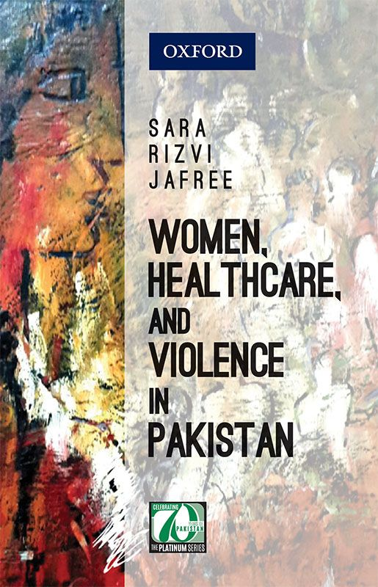

PKR 950

[ADDITIONAL INFORMATION](https://oup.com.pk/academic-generalbooks/sociology-gender-studies/women-healthcare-and-violence-in-pakistan.html#additional)

|  |  |
| --- | --- |
| More Information | |
| **ISBN** | 9780199406067 |
| **Weight in kg** | 0.455 |
| **Rights** | World |
| **Year of Publication** | 2017 |
| **Binding** | Hardback |
| **Pages** |  |

Top of Form